Ex.no:6c | DATA VISUALIZATION USING POWER BI

Aim:
To Load the data into PowerBI and transform the data and visualize it to get insights

Algorithm: Chess Games Dashboard Calculation
Step 1: Input Data Loading

Read the dataset from games.csv containing columns:

id, rated, created_at, last_move_at, turns, victory_status, winner, increment_code, white_id, white_rating, black_id, black_rating, moves, opening_eco, opening_name, and opening_ply.

Dataset contains 20,058 chess game records.

The winner column represents the game result:

White → White player won
Black → Black player won
Draw → Game ended in a draw

The dataset contains:

10,001 White wins
9,107 Black wins
950 Draws
Step 2: Rated Filter Check

Check the slicer selection for Rated.

Available rated categories:
True
False

Default selected categories:
True
False

Retain all game records matching the selected rated categories in Filtered_Data.

Step 3: KPI Total Chess Games Calculation

Count all records from Filtered_Data.

Total Chess Games:

20,058

The KPI card displays the value as:

20.1K

Calculate the game percentage using:

Game Percentage = (Number of Games / Total Games) × 100

Step 4: Bar Chart Calculation

Number of Chess Games by Winner

Group Filtered_Data by winner.

Count the number of games for each winner category.

The bar chart displays the number of games for:

White → 10,001
Black → 9,107
Draw → 950

Sort the winner categories in descending order according to the number of games.

The resulting bar chart represents the distribution of chess games according to the winner.

Step 5: Donut Chart Calculation

Number of Chess Games by Winner

Group Filtered_Data by winner.

Count the number of games for each winner category.

Calculate the percentage share of each winner relative to the total number of chess games.

Formula:

Winner Share = (Games Won by Winner / Total Chess Games) × 100

The donut chart displays:

White → 10,001 (49.9%)
Black → 9,107 (45.4%)
Draw → 950 (4.7%)

The center of the donut chart displays:
20.1K

The total represents the overall number of chess games.

The percentage labels represent each winner's contribution to the total chess games.

Step 6: Dashboard Render

Render the KPI card with the formatted total chess games:

20.1K

Render a vertical bar chart showing:

Number of Chess Games by Winner

Render a donut chart showing:

Number of Chess Games by Winner

Render a Rated slicer containing:
True
False
On slicer selection, filter the chess game records according to the selected rated categories.

Recalculate the KPI value, bar chart, and donut chart based on the filtered data.

The dashboard therefore provides an interactive analysis of chess game outcomes according to winner and rated-game status.

Output:

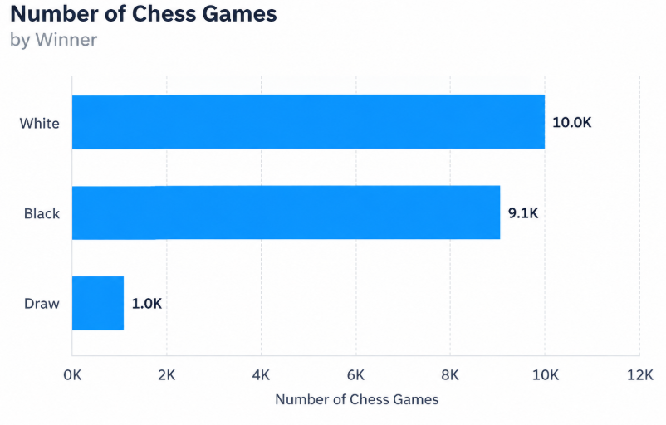

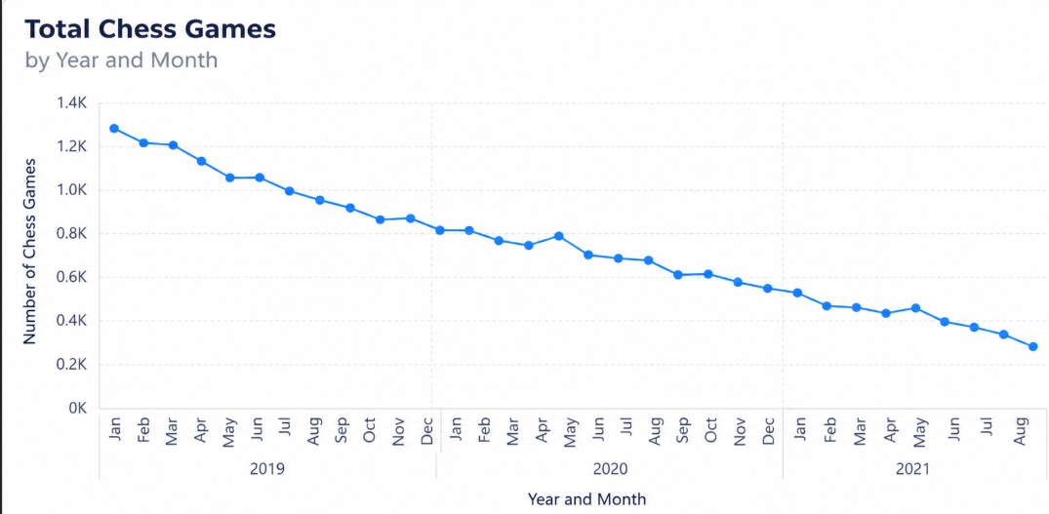

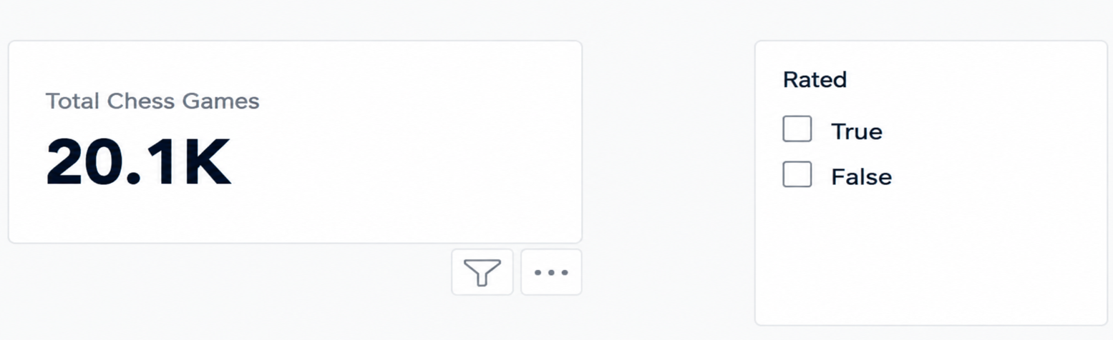

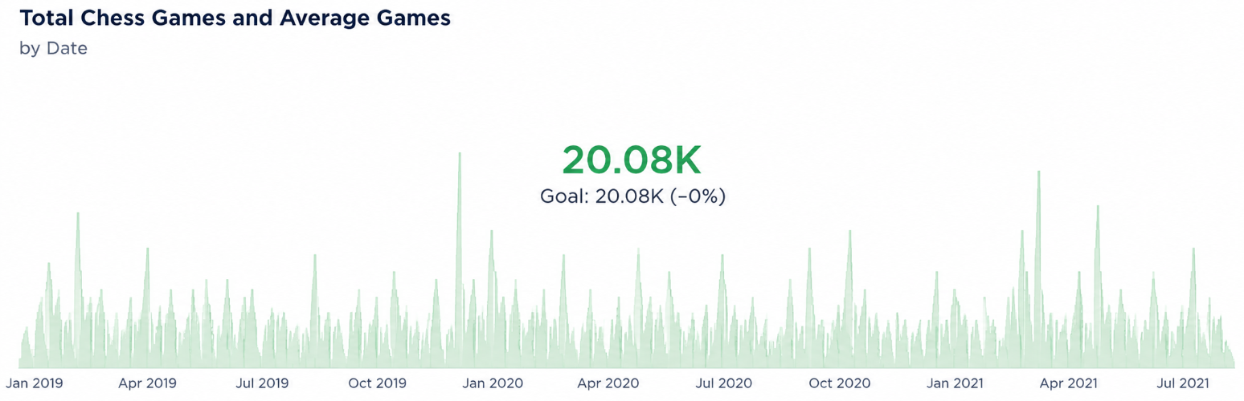

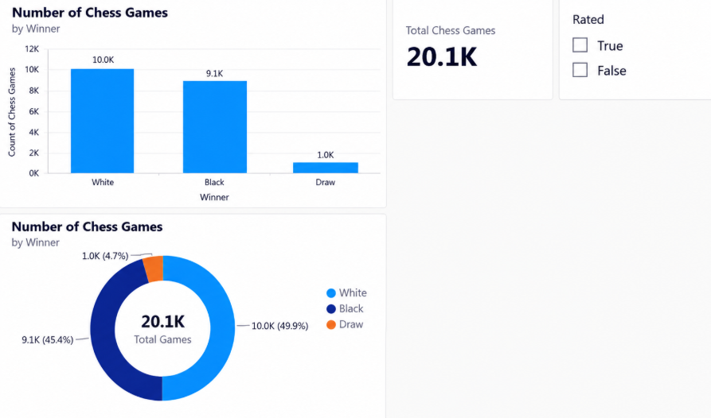

Result:

